Title: Boop Bap 🤖

# Main Idea:

SOUnD travels to the future (2100-2500ish?) and encounters a group of androids powered by ChatGPT o3000-mini-high (O 3000?!?!? 🤯). The robots are able to play without the use of instruments and instead rely on sensors on their body (as seen below) to play any sound they want. However, they face some technical difficulties and aim to reboot their system to reach peak performance again.

Happens after electric piece?

Budget:

PCB Production:

Shipping x2: At least $22.4 each iteration

[https://pro.easyeda.com/editor#id=193c6e2f277d44478b8056e6bffdea83,tab=*2e04828190714d1e937f3f34cfa52983@193c6e2f277d44478b8056e6bffdea83](https://pro.easyeda.com/editor#id=193c6e2f277d44478b8056e6bffdea83,tab=*2e04828190714d1e937f3f34cfa52983@193c6e2f277d44478b8056e6bffdea83)

Sensors:

Wireless transmitters:

At least $50

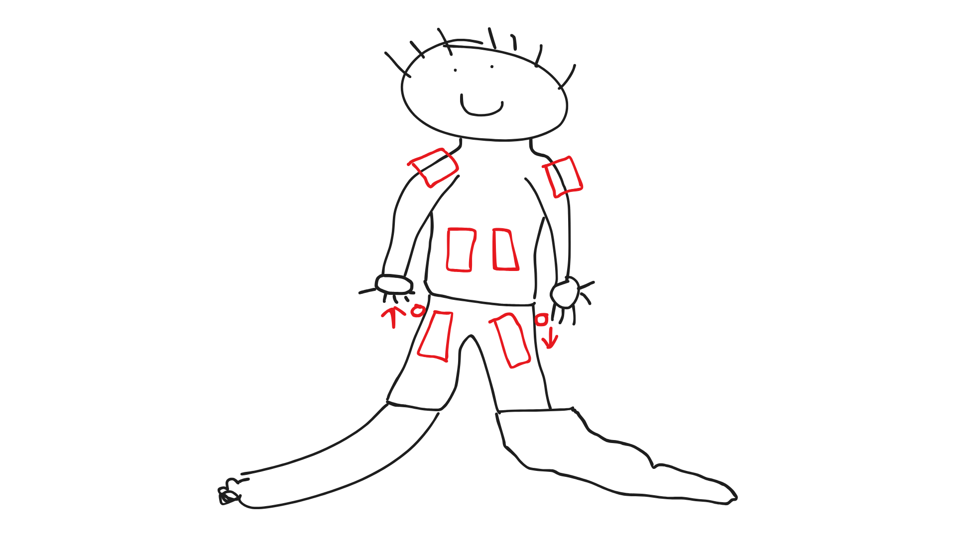Figure 1

# Instruments:

* Each person has 6 sensors attached (or 8??) to them with two buttons on the side of their leg to control dynamics.

### Instrument Sounds:

* Players 1-3 (start house left): 6 sensors each, all MIDI
* Players 4-6 (start mid): 6 sensors each, 2 on each shoulder are mapped to percussion, the remaining 4 are MIDI
* Players 7-9 (start house right): 6 sensors each, all MIDI
* Soundfonts: Mixed EDM?, 8-bit, square wave/synth, orchestral hit, windows reboot, usb plugin, breakcore drum SF, general perc.
* Experiment with bass/treble/high

### Visual Effects:

* Sensors light up when touched. Mapped to red, green, pink, blue, orange, yellow, purple, teal
* Terminals/consoles set up on main stage (thanks creative)? Left, mid, right. One (mid probably) has the actual laptop running the server receiving the wireless signals and producing audio output. Left and right can be speakers outputting parsed audio.
* During “reboot” section in the middle of the piece, lights go off and we play in the dark for a bit. Experiment with dark red lighting (like emergency power)
* Dr. Who TARDIS in the back?
* Big red reboot button in the middle? Will be pressed by human

# Creative Outline:

* Humans enter, meet robots in emergency power mode
* “Androids” talk in robot voice and do robotic movements
* “It's not a bug its a feature”
* Piece starts
* Reboot, Windows shutdown/shartup sound
* Androids begin moving more fluidly/better
* USB plug in/unplug sound effect
* End piece
* “The energy needed to power gpt for that piece just evaporated lake erie (or some other big power source)”

# Musical Sections:

Start with dim lighting? See if theater has it

* Polyrhythm heart beat entrance
  + House right red, house left blue
  + Angelic chord progression?
  + [Living Island](https://youtu.be/ttQSs35Z7nE?si=tBLx-VX5fk61tlLP)
  + [Enchanting Grom Fright but it's electroswing](https://youtu.be/habQUBdSYI4?si=cV9gBArncbWNmTb8)
  + [Stardew Valley OST - Journey Of The Prairie King - Overworld](https://youtu.be/yaBNr6zv0ek?si=GkUIQdCq0E8t42dG)
  + <https://www.tapspace.com/percussion-ensemble/mayhem>
  + [Into the Air (Marimba Duet) - Ivan Trevino](https://youtu.be/epJ3_-WPSt4?si=yjH05Y5ov66w7hQx)
  + [Fractalia by Owen Clayton Condon, performed by Third Coast Percussion](https://youtu.be/bs_yMbao7IQ?si=M195pncwNaYpno1B)
  + [Catching Shadows - Percussion Sextet](https://youtu.be/e8zzOtKJgSc?si=s9SgIFPg4y4ucGYf)
  + [2+1 Marimba Duo, by Ivan Trevino](https://youtu.be/f-ySoa1qddg?si=XpU1RZOpVaZa2HH-)
  + [Patricia Taxxon - Retrograde](https://youtu.be/Jf5kc4KKLZM?si=qnbXibDEWpr5uhqL)
* Backshot formation (Pipes feature-like)
  + House left - bass
  + House right - high treble
  + House mid - drum kit
  + [Bald Guys](https://www.instagram.com/reel/DDW3htATKOZ/?utm_source=ig_web_copy_link&igsh=MzRlODBiNWFlZA==)
  + 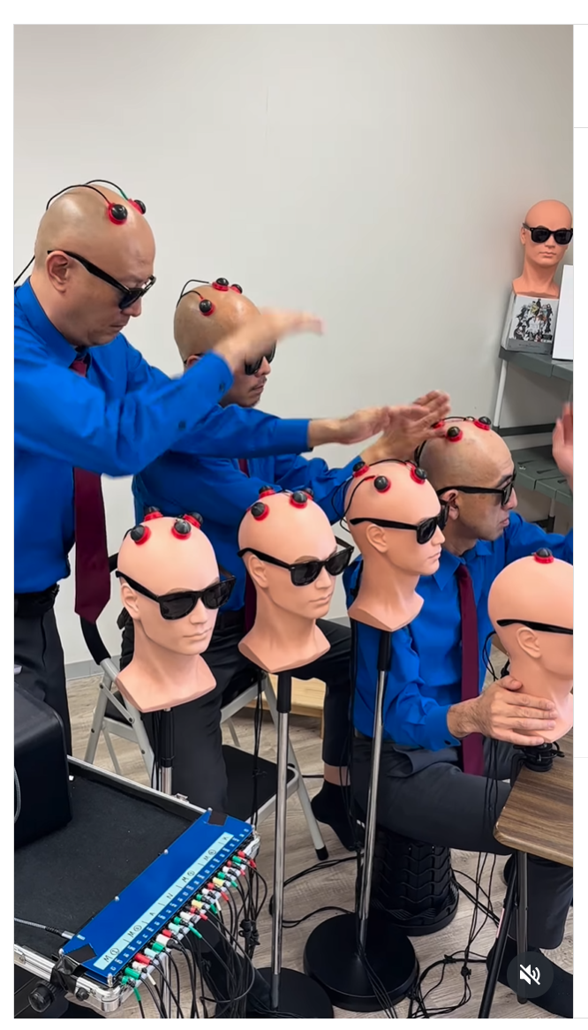
  + “Is your forehead big enough to fit two of those johnsons on there?” - Ben
    - this is a warning
* Reboot
  + [Windows error song. DJ prank](https://youtu.be/NfUeUCErCmQ?si=5IJCziGCNMHorIuh)
* Windows startup sound, USB-plugin
  + [Windows 10 USB Cable Plug/Unplug Sound Effect](https://youtu.be/ENa4dTrnMsc?si=suwEaSfSe-be_xMF)
* Finale

# Device Schematic/Layout:

* Sensors ->
  + 6 (or 8) MIDI sensors designated to sound output, placed as seen in figure 1
  + 2 volume sensors mapped to dynamic control, sides of thighs
  + Velcro or magnet attached to clothing, or some other attachment method
  + Black wires connecting them to the pins on the microcontroller
  + Lights up with colors = [red, green, pink, blue, orange, yellow, purple, teal]
* Packaged microcontroller device ->
  + PCB board
  + Power source
    - Battery? Hopefully rechargeable but ok if not
  + Flash firmware
    - MicroUSB serial port
  + Debug output
    - JTAG emulator? Maybe not necessary for production version
  + Pin input -> CPU
    - Send signals for sensor on/off so notes can be held out
  + Wireless communication
    - Easiest answer is bluetooth, but faster outputs that are less restricted are preferred for precise timing
  + On button (preferably really easy to see if it’s on)
    - Starts client connection to server at {ip address}
  + Packaging / case
    - Should be able to fit in back pocket of jeans, aim for thin
* Server ->
  + Receives wireless input from 9 microcontrollers
  + Easy way to write is [Node.js](http://node.js) but that could be slow since single threaded
  + Probably will use C or C++ to write server
  + Run on high compute laptop with 4 or 8 cores (josh or jessicas if it works) or a computer if i decide to just bring it
  + Parse 9-way TCP/IP socket input
  + Parse message (device_id, sensor_id, sensor_cmd) 3 bytes total
  + Switch (device_id), switch(sensor_id), if (sensor_cmd)
  + Alternatively, just hash commands into functions sent to the speaker
  + Play soundfont samples corresponding to the device[sensor_id]
  + Do stereo output?
  + Handle dynamics and multiple input of the same audio
  + Maybe use some mathematical function so that audio volume isn’t disproportionate when stacked 9 times
* Speakers
  + Hopefully wired to laptop, otherwise wireless
  + Directional audio?